**Slow website load speed**

**Used Device/Browser:**

* Chrome Version 104.0.5112.102 (Official Build) (64-bit) on Windows 10

**Steps to reproduce:**

* Open the <https://gtmetrix.com/> page
* Paste the link <http://www.007museum.com/index.html> into the input bar found on the website
* Click the button “Test your site”
* Wait for test report
* Repot received during my testing found in screenshot below

**Screenshot:**

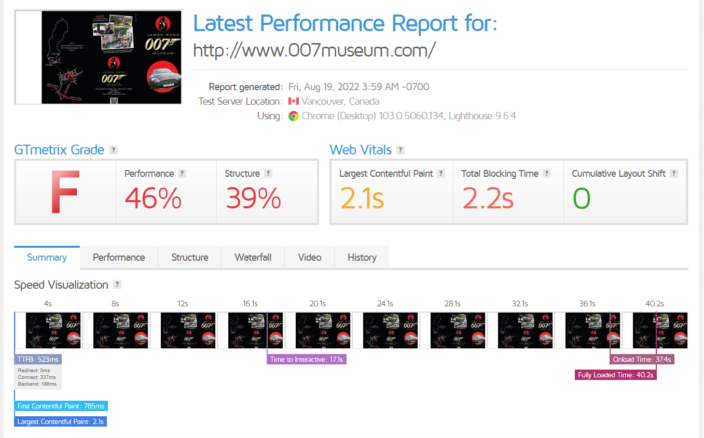

**Several ‘Facebook’ linked images**

**Used Device/Browser:**

* Chrome Version 104.0.5112.102 (Official Build) (64-bit) on Windows 10

**Steps to reproduce:**

* Open the <http://www.007museum.com/index.html> page
* Browse to the bottom of the header main image
* Under the image you will find several Facebook linked images taking the user to different Facebook pages (shown as circled red on screenshot below)

**Screenshot:**

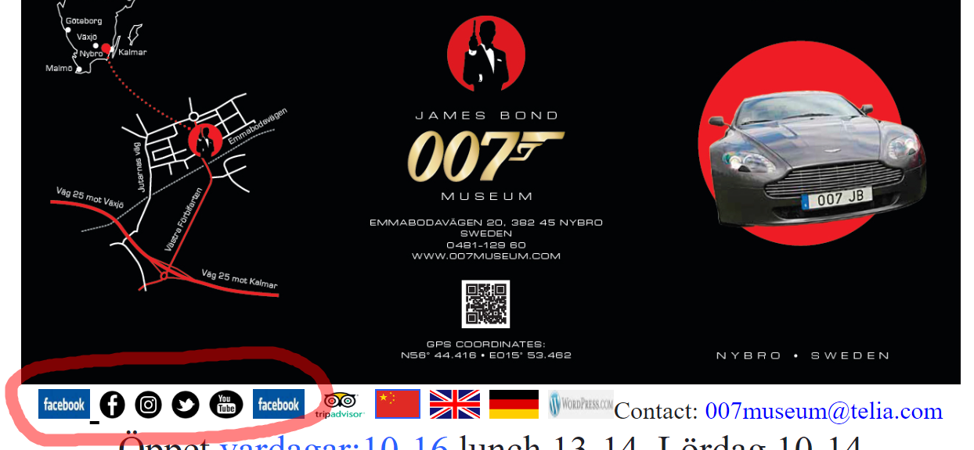

**Image not centered**

**Used Device/Browser:**

* Chrome Version 104.0.5112.102 (Official Build) (64-bit) on Windows 10

**Steps to reproduce:**

* Open the <http://www.007museum.com/index.html> page
* Browse to image as seen on screenshot
* See the image is not centered and doesn’t follow the content flow

**Screenshot:**

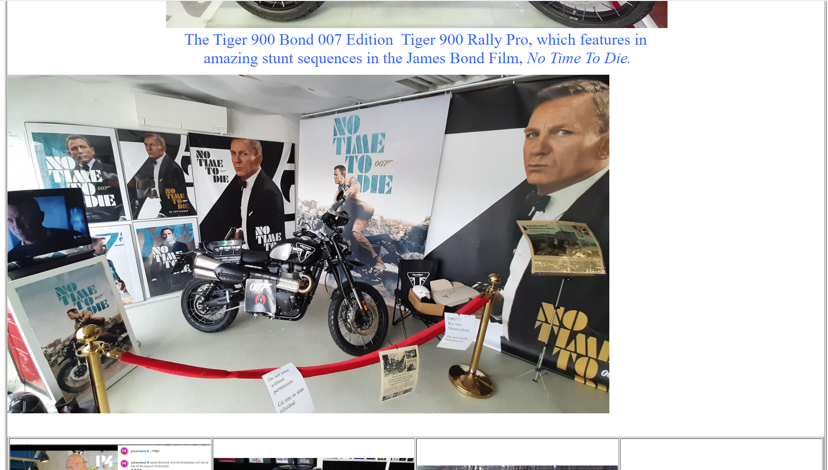

**Content falls out of the flow**

**Used Device/Browser:**

* Chrome Version 104.0.5112.102 (Official Build) (64-bit) on Windows 10

**Steps to reproduce:**

* Open the <http://www.007museum.com/index.html> page
* Browse to image as seen on screenshot
* See the following content breaks from the flow of previous content

**Screenshot:**

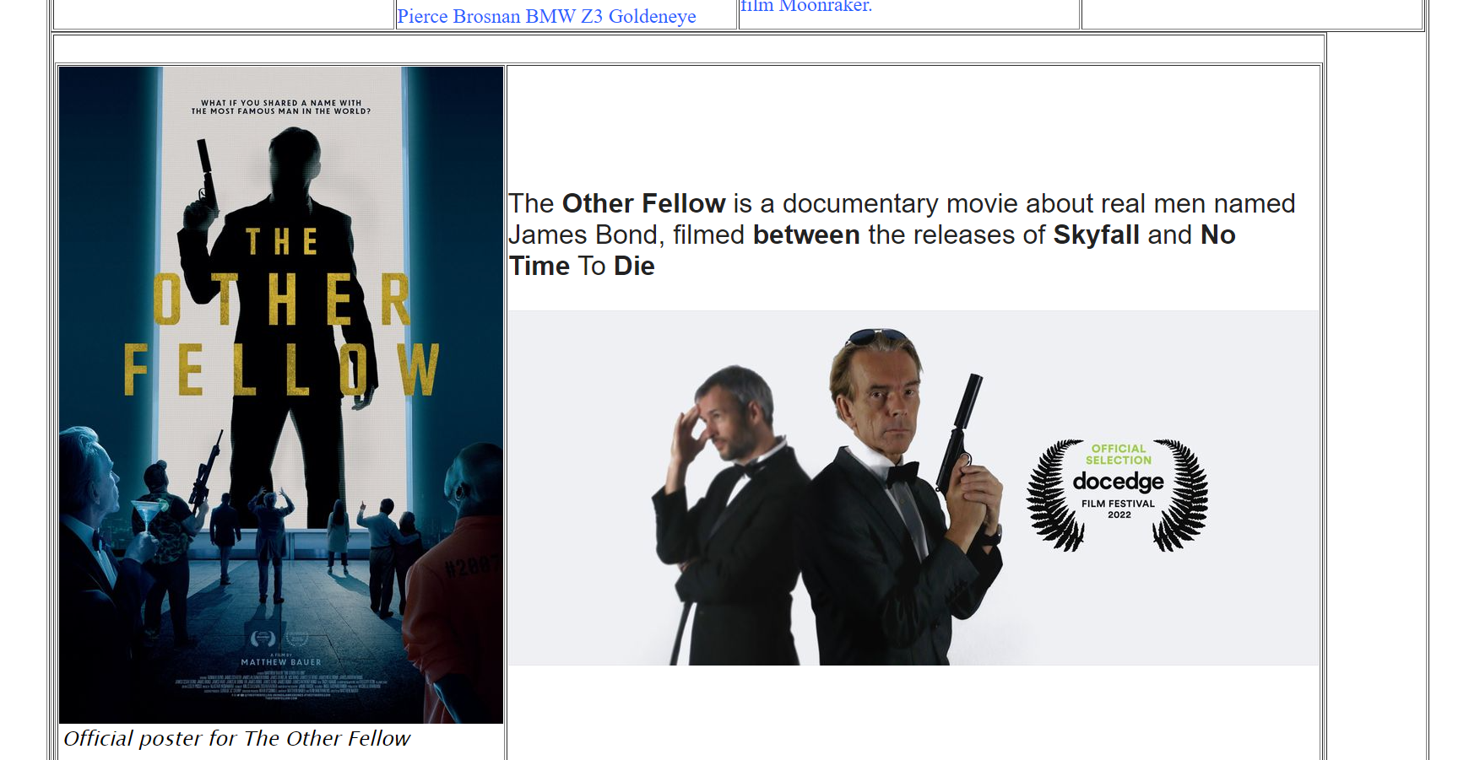

**Content falls out of the flow, aligned left**

**Used Device/Browser:**

* Chrome Version 104.0.5112.102 (Official Build) (64-bit) on Windows 10

**Steps to reproduce:**

* Open the <http://www.007museum.com/index.html> page
* Browse to section as seen on screenshot
* See the following content breaks from the flow (wrapper) of previous content, content is aligned left

**Screenshot:**

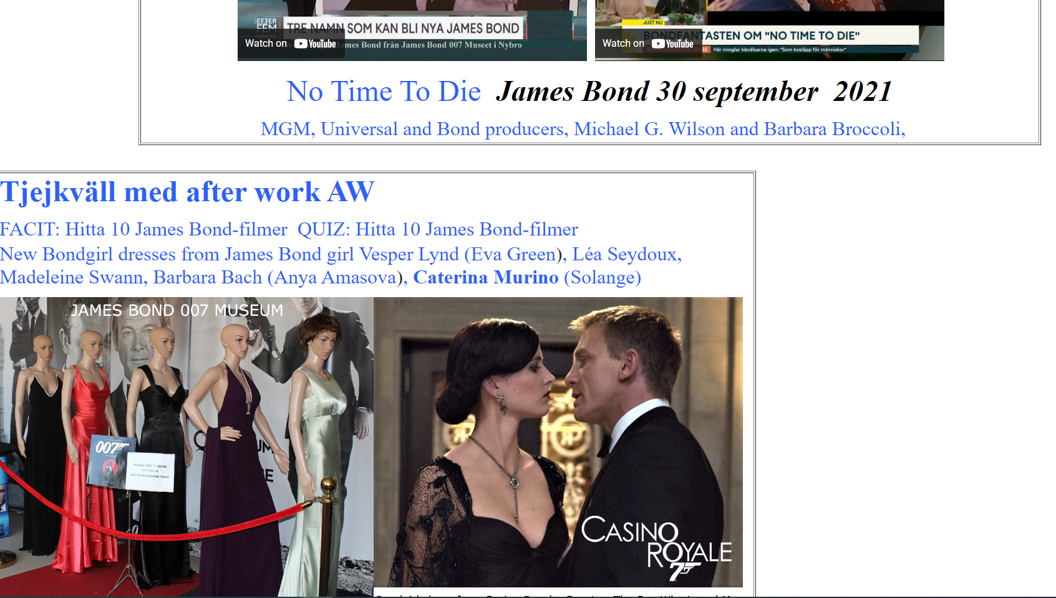

**Multiple sections fall out of content flow, aligned left**

**Used Device/Browser:**

* Chrome Version 104.0.5112.102 (Official Build) (64-bit) on Windows 10

**Steps to reproduce:**

* Open the <http://www.007museum.com/index.html> page
* Scroll through content
* Check sections that are aligned left and thus fall out of content flow, the centered wrapper as seen in video linked below

**Screenshot:**

<https://screencast-o-matic.com/watch/c3jqXqVT2dl>

**Clicking on link to the location of the museum doesn’t show the location on map but the whole world**

**Used Device/Browser:**

* Chrome Version 104.0.5112.102 (Official Build) (64-bit) on Windows 10

**Steps to reproduce:**

* Open the <http://www.007museum.com/index.html> page
* Scroll down and click on circled hyperlink as shown on the screenshot (1) below
* You will be taken to a new page
* Scroll down to map as seen on screenshot (2) below not showing the location of the museum but the world

**Screenshot:**

1.

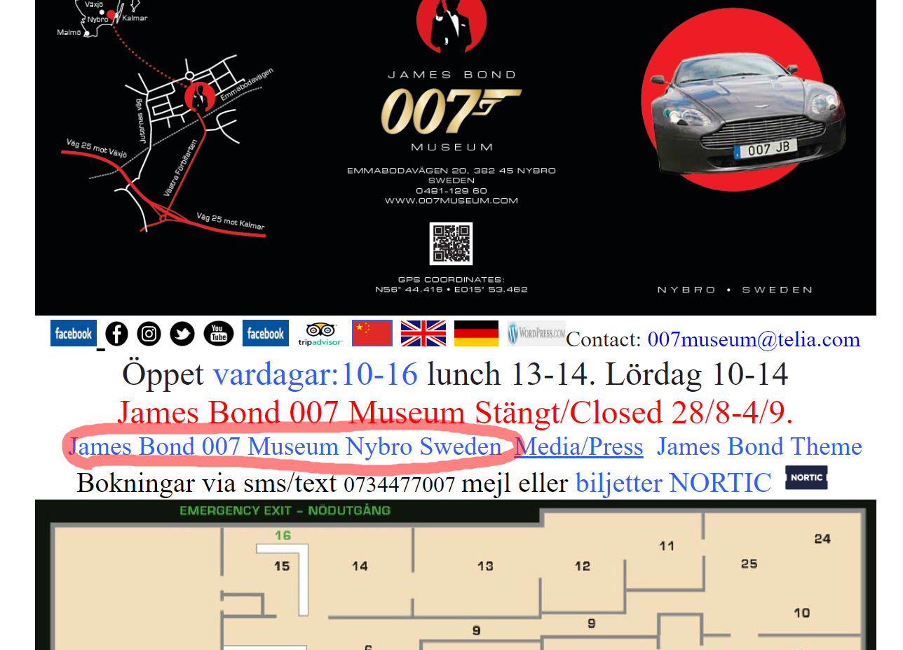

2.

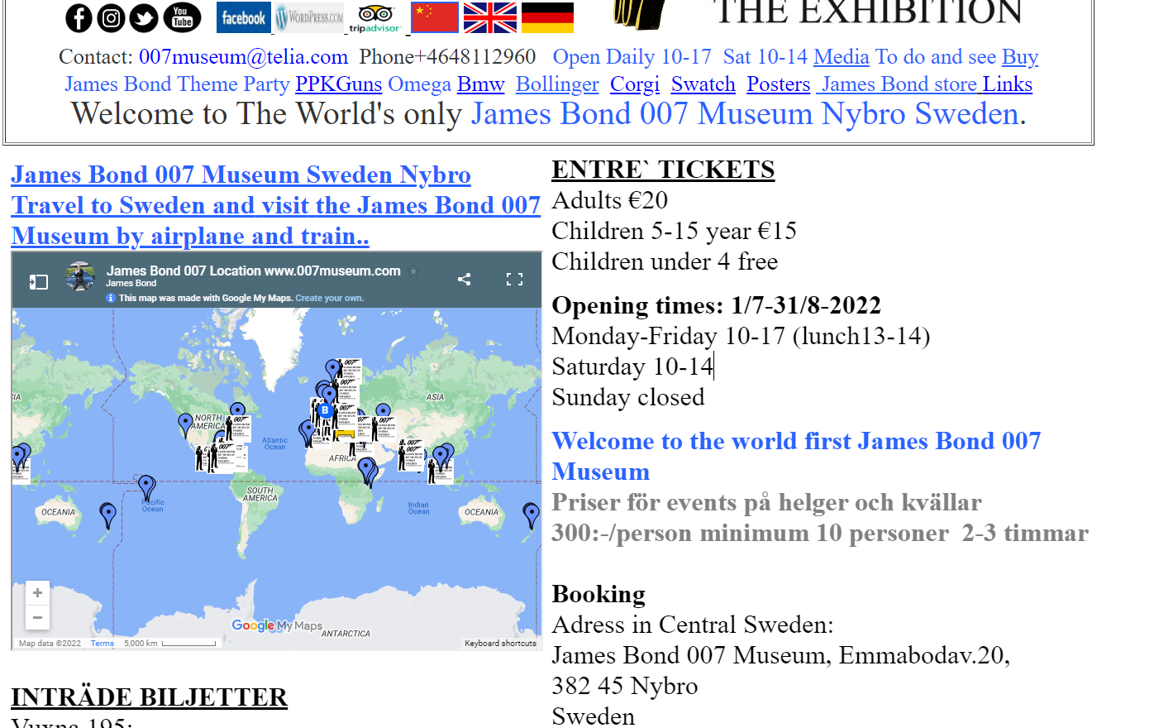

**Overlapping text**

**Used Device/Browser:**

* Chrome Version 104.0.5112.102 (Official Build) (64-bit) on Windows 10

**Steps to reproduce:**

* Open the <http://www.007museum.com/nybroatlas.htm> page
* Scroll down to section of the page as seen on the screenshot below
* On the left-hand side of the page you will see overlapping text

**Screenshot:**

